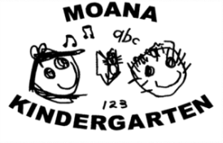
Beach Kindy
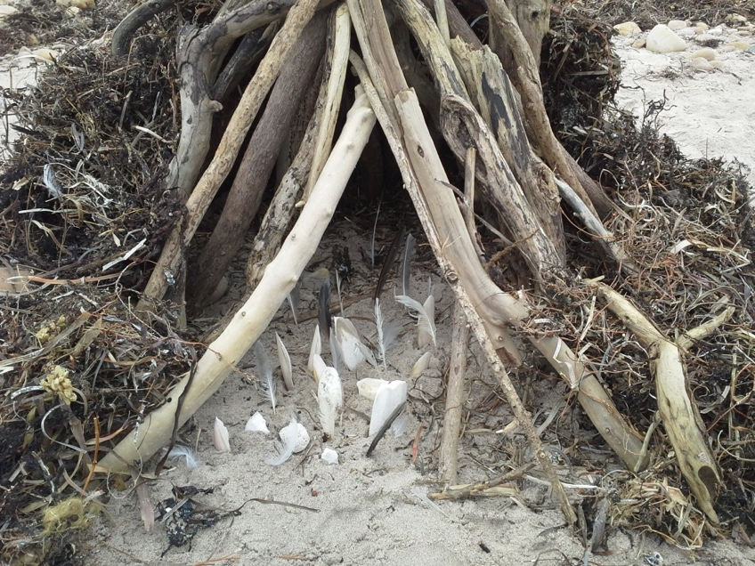

We cannot protect something we do not love, we cannot love what we do not know, and we cannot know what we do not see. Or hear. Or sense. Richard Louv

Beach Kindy

Contents

- Belief Statement

- Benefits of Beach Kindy

- Beach Kindy Safety

- Location: Moana Beach Foreshore

- What you need for Beach Kindy

Look deep into nature and then you will
understand everything better.
Albert Einstein

Beach Kindy Belief Statement

Beach Kindy affords students experiences to develop a sense of connection to their local beach environment. It links learning at kindy with the world beyond and presents many opportunities for taking calculated risks and in turn developing resilience.

Visiting on a frequent and regular basis allows for sustained exploration, the development of student led inquiry and provides a rich environment for collaborative learning. This harnesses children’s sense of wonder, awe and stewardship whilst also benefiting social and emotional development.

The approach is sustainable and rights-based and aims to maximise the play and learning opportunities this gives to very young children through practical, authentic outdoor experiences.

The more risks you allow children to make, the better they are at looking after themselves. Roald Dahl
Benefits of Beach Kindy
Moana Kindy offers weekly opportunities for a group of children to visit Moana Beach. The aims and objectives of these sessions are:
* To give children time to experience free play in a natural setting on an ongoing basis.
* To help children develop a connection with the natural world and to learn about nature and how to care for it in a context that is relevant to their lives and in their local community
* To learn the practicalities of how to be outside: personal safety, hygiene, coping with weather and different terrain.
* To offer experiences which are different to that which happen in the outdoor space, back at the kindy whilst also developing dispositions for learning
* To develop specific interconnected learning behaviours that facilitate children’s learning processes of Numeracy and Literacy in a real-world context
* To learn first-hand, the importance of sustainability and practices to care for the environment and develop a sense of stewardship in all.

'It's better to know one mountain than to climb many.”
Native American Indian saying
Beach Kindy Safety

Risk Assessments
Together educators and children conduct risk assessments of their physical space each session and discuss “how to be safe in this place’ This includes an assessment of everything within a ‘head, shoulders, knees and toes’ line of sight. This empowers children with the skills and responsibility for making choices that consider and reflect their learning about ‘how I keep myself safe’

Emergency procedures
We regularly revisit and practice procedures with children. Staff regularly review current guidelines and processes, all of which are documented in the Beach Kindy Handbook.

Extreme Weather
In extreme weather; ie high winds, thunder, lightning, extreme heat (over 34 degrees) Beach Kindy sessions will be postponed or ceased and moved back to Moana Kindy site. Where possible, parents will be notified of cancellation the evening of the day before the planned session (via text message from Kindy mobile).

Hygiene and Safety
Children will have access to bathrooms for toileting and handwashing. First-aid kits will be carried, and all educators hold current first aid qualifications. A common-sense approach prevails.

Safety around local flora and fauna
Children are naturally inquisitive, and they will be supported to explore the local beach environment for flora and fauna in its natural habitat. Respectful interactions will be supported and creatures that pose a risk will be dealt with in an appropriate manner. Copies of the Nature Play SA Adventures by the Sea Field Guide will be on hand to support these investigations.

Location: Moana Beach Foreshore

Moana Beach, 322 Esplanade,
Moana Beach SA 5169
Parallel to public toilets
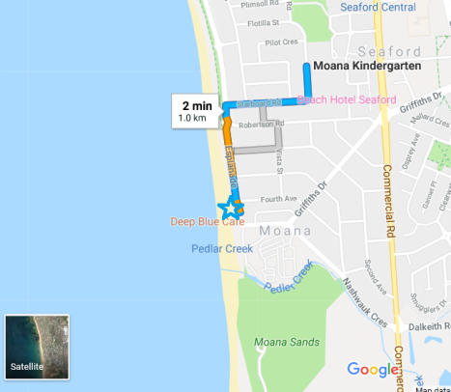

Acknowledgment of country

As we wander along the coast line, we aim to learn about the traditional owners of the land we walk upon. About their spiritual and cultural beliefs, Dreaming stories connected to county and the many traditional uses of the land and sea.

What you need for Beach Kindy

- Hat (legionnaires or bucket - NO CAPS)

- Fruit and lunch box (with Ice pack in It for increased food safety)

- Red Beach Kindy t-shirt (with the name and contact number of Kindy). Provided at sign in to wear for the entirely of the session.

- Spare socks and clothing in your child’s bag

- Provide a plastic bag to put wet clothes in (biodegradable or reusable if possible)

- Appropriate footwear for walking back to Kindy after Beach session

- Drop your child off at 9.00am at Moana beach(you will sign into the session with the session leader - they will be wearing a high visiblity vest, then children will be taken to beach Kindy home base)

- Collect your child from back at the Kindy at regular pickup time.

A handout for parents to display and refer to at home

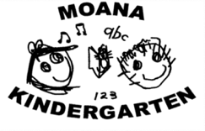
Getting ready for my
Beach Kindy day

Before I go

Learning Intention: I can get ready

- Locate their backpack
- Put in their snack and lunch
- Put in their drink
- Put in any other items needed
- Zip up their back pack
- Put their backpack on

When I arrive

Learning Intention: I have done all my jobs when I arrive

- I have gone to the toilet with my parent or carer
- I have signed in to Beach Kindy (session leader will greet you - look for high visibility vest)
- I have put my Beach Kindy t-shirt on
- My bag is stored in the right place
- I have joined the group at beach kindy 'home base'

Beach Kindy Learning Intentions

Learning Intentions that will be embedded into a Beach Kindy session include;

- We know the boundaries
- We can be safe in a public place
- We are aware of the sea
- We are aware on the beach
- We can manage ourselves around rocks and rock pools
- We can eat fruit/lunch outside and know the hygiene process
- We know how to be safe ‘in this place’
- We can sort our backpacks after an off-site visit
- We can be safe on the journey walking back to Kindy

Please note: Sibling involvement
These sessions are a special time for the Kindy aged children and value four-year-old learning. For this reason, siblings will not be able to stay at the sessions (as per a normal Kindy session). Volunteer parent’s full attention will be required to ensure the wellbeing and safety of enrolled Kindy students.

