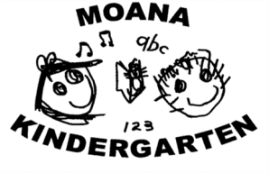

Beach Kindy: Handbook
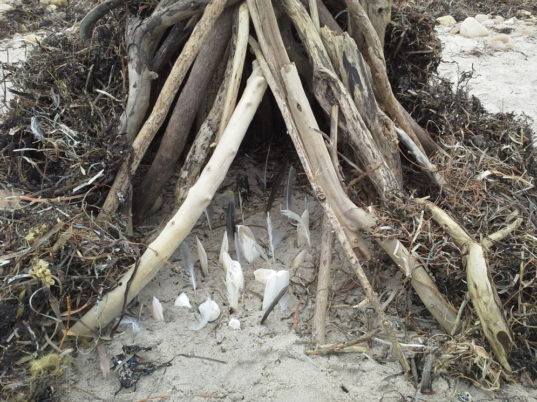

Contact details
Sophie Northcott  Director  Schooner Road  SEAFORD SA 5169  Telephone: (08) 8386 1971  Facsimile: (08) 8327 2852  Email: dl.3690_leaders@schools.sa.edu.au  Onkaparinga Council Contact:  Eulonda Bolger  Property Officer (Leases, Licences and Permits)  Phone: 8488 2003 | Beach Kindy Location:  Moana Beach, 322 Esplanade,  Moana Beach SA 5169  Parallel to public toilets  Coordinates:  35°11'51.6"S 138°28'13.4"E  -35.197659, 138.470386  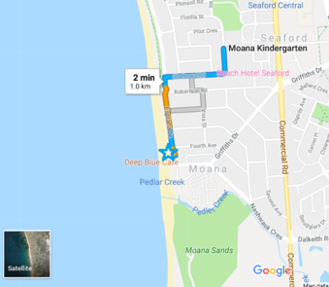
This handbook should be read by all staff involved in the Moana Beach Kindy Visits and volunteers. It should be updated as needed but at least on annual basis and when new staff are involved. Last update 21/8/18

Beach Kindy Handbook

CONTENTS

- Aims and objectives

- Before going to the Beach Kindy Site

- Getting there and back

- At the Beach Kindy site

- Guidelines and Policies

- Emergency Procedures

Appendix 1: Daily site check form
Appendix 2: Equipment List
Appendix 3: Visit leader’s checklist
Appendix 4: Daily off-site register
Appendix 5: Site information checklist
Appendix 6: Site appraisal
Appendix 7: Visit plan checklist (V1 form)

These appendices should all be completed along with risk benefit assessments prior to Beach Kindy visits going ahead. Please ensure your Director has seen and signed off the risk benefit assessments.

Department for Education Requirements
The guidelines and processes outlined in this handbook reflect Moana Kindergarten’s site-specific excursion policy, which adheres to all Department for Education policy. All elements of Beach Kindy have been risk assessed and risk benefit analysis’ completed as a staff group and with children. Ratios for supervision meet all necessary guidelines. This document has been developed by the staff at Moana Kindy in collaboration with Nature Play SA. The Governing Council, families and children were also consulted throughout the process. This handbook is to be reviewed annually and was last updated on 21/8/18

- Aims, objectives and overview

Moana Kindy offers ongoing opportunities for a group of children to visit Moana Beach. The aims and objectives of these sessions are:

- To give children time to experience free play in a natural setting on an ongoing basis. (Early Years Learning Framework Outcome 3: Children have a strong sense of wellbeing)

- To help children develop a connection with the natural world and to learn about nature and how to care for it in a context that is relevant to their lives and in their local community (Early Years Learning Framework Outcome 2: Children are connected with and contribute to their world)

- To learn the practicalities of how to be outside: personal safety, hygiene, coping with weather and different terrain, along with connecting with Aboriginal culture and the importance of connection to land. (Early Years Learning Framework Outcome 3: Children have a strong sense of wellbeing and a strong sense of identity: Learning Outcome 1)

- To offer experiences which are different to that which happen in the outdoor space, back at the kindy whilst also developing dispositions for learning (Early Years Learning Framework Outcome 4: Children are confident and involved learners) and opportunities to develop associated communication skills (Early Years Learning Framework Outcome 5: Children are effective communicators)

- To develop specific interconnected learning behaviours that facilitate children’s learning processes of Numeracy and Literacy in a real-world context (Learning processes in the Indicators of Preschool Numeracy and Literacy)

The aim of this handbook is to provide staff, volunteers and others with information about the ongoing visits to our Beach kindy site.

Policies and procedures

The Moana Kindy community have established a Beach Kindy program to connect learning off site with site-based inquiry; to develop a culture where visits to the local beach on a frequent and regular basis, inform the learning that happens within their grounds. The approach is sustainable and rights-based and aims to maximise the play and learning opportunities this gives to very young children through practical, authentic outdoor experiences.

Whilst a Beach Kindy session is in place, the policies and procedures that are normal part of our practice apply. We make appropriate adaptations to practice and ensure that this is an opportunity for children to transfer skills to different context and make the most of learning opportunities which cannot happen on-site.

In addition, we take account of local and national guidance that is relevant to off-site visits. These include local council regulations and policies relating to; volunteers, sun-smart practices, inclement weather, excursions and off-site visits. This program also reflects guidelines and recommendations from the National Quality Framework, Quality Area 2: Children’s Health and Safety (ACEQA.) The child protection policy and practice of Moana Kindy applies at all times throughout the visit.

Management and staffing

The learning community at Moana has for a number of years used the beach as an integral part of their yearly program, accessing the resource it provides in a number of different capacities including; excursions to the local beach areas such as the Middens (sand dunes) and connect with local aboriginal people, Moana Beach, Pedlar Creek and connecting with the surf lifesaving club.

The staff proactively liaise with the Onkaparinga Council and local community to ensure that any issues which arise are considered and dealt with as appropriate.

One staff member will assume the role of visit leader for each session and they will ensure all elements of preparation and planning have been undertaken to make each visit run smoothly. They will assume overall responsibility for the session. The Equipment and Visit Leader’s Checklists (Appendix 1 and 2) are used to ensure that all the equipment is ready, and the children are prepared.

To develop this program, staff consulted and worked in partnership with Maria Taylor from Nature Play SA and Laura Mathews (Department for Education).

Supervision and ratios

The child: adult ratios put in place for Moana Beach Kindy aims for a ratio of 1:4 (but this is risk assessed determined for the specific needs of the children) and have considered:
- The number of children in the group and their specific needs.
- The journey to and from the site.
- The range and nature of play opportunities available at the site.
- The environment at the site.
- The weather and seasons.
- The abilities and experience of the volunteer adults.

Prior to the visit going ahead, a site appraisal was undertaken to consider its suitability for the Beach Kindy sessions and the local council consulted. An application for the ‘Use of a Foreshore area or reserve’ was submitted to council

Recording systems

The recording systems used at Moana Kindy apply to the Beach Kindy sessions.
The visit leader ensures that the following are always with the group:
- At least one fully charged mobile phone with sufficient credit is with the group and all staff know its location.
- The Moana Beach Kindy site has reasonable phone reception – no black spots are known.
- A register of adults and children present on the day is kept in a known, central location.
- First aid records are kept with the first aid kit in an agreed location known to all – portable first aid backpack.
- A system for observing and recording significant learning moments is used throughout the session, in a similar way to documentation used at Kindy. This will include the use of Floor books, observation records and photographic/video evidence.
- Emergency contacts and personal information will be kept with Beach Kindy Leader.

A positive approach to risk in play

We take a balanced and proportionate approach to the management of risks. We consider the benefits of the sessions and ensure these significantly outweigh any identified serious risks in line with our curriculum and National Guidelines.

Measures are put in place to manage these risks of the overall environment and travel to and from the sites being used.

Comprehensive risk benefit assessments of the Beach Kindy site have been undertaken, including a site visit and assessment by all staff, site check before and on the day of Beach Kindy and assessments with children (How can I be safe in this place?)

The risk benefit assessments are reviewed as needed but at least on an annual basis. The Kindy Director checks and signs these forms as part of the process to ensure the visits are as safe as necessary.

Children are encouraged to self-assess and manage the risks appropriately through their play. We use phrases which help children consider the issues but avoid giving the impression that it is dangerous being outside, such as:
- “What do you need to remember when we play on the beach?”
- “What do we need to check before we do this?”
- “What advice can you give the new parents and children about ….?”

We take a rights-based approach to managing common risks when off-site in line with the age, stage and ability of each child or group and the competence of the staff team. Children at the kindy take risks every day! Whether its tree climbing, wearing no shoes whilst outside in nature, swinging upside down on the ropes or hammering nails into a piece of wood. There is no stopping our courageous children here at Moana Kindy.

Taking risks helps children to decipher for themselves what they can and can’t do at their own individual level, whilst building self-courage. Creating strong and confident children who can take on the world!

By taking such an approach to children’s exploration of their environment, we are helping children develop independence, confidence and resilience. They are able to expand their learning and stretch their abilities.

Parental involvement

The Moana Beach Kindy visits rely on the goodwill and support of parents to volunteer. We value their input and educate parents to the benefits of the visits by:
- Welcoming displays with photos and information about the Beach Kindy sessions.
- Providing information at induction sessions.
- Newsletters and information boards, The Floor Book and parent handouts have regular updates about the Beach Kindy sessions.
- Having a Beach Kindy visit as part of the induction process (2019).
- Seeking parent volunteer’s opinions to gain ideas to feed into making the visits even better.
- Observing and recording significant learning moments to share with parents whilst at the Beach Kindy sessions.
- One-to-one discussions are available when children are collected or dropped off.
- Providing the Beach Kindy Handbook for volunteer parents.
- Volunteers will be buddied up with a staff member for additional support and may be assigned a small group of primary care children depending on experience.
- Collaborating with children from Moana School at the Beach Kindy site.
- Inviting partner organisations (Such as Nature Play SA, NRM Education, Surf Life Saving South Australia) and outdoor professionals to work with children at the Beach Kindy site as a one-off or series of special events to which parents are also invited.
- Parents are involved in assessing and understanding risks and considering how they will be managed e.g. through the daily site check.
- A parent letter that is issued prior to the start of the Beach Kindy sessions that informs them of details relating to sessions.
- These sessions are a special time for the Kindergarten age children and value four-year-old learning. For this reason, siblings will not be able to stay at the sessions as volunteer parent’s full attention will be required to ensure the wellbeing and safety of enrolled Kindergarten children.

Parent Volunteers

The use of volunteers follows Department for Education Volunteer Policy

Clothing and footwear

Given the possibility of changing weather and UV Index, children and adults have suitable clothing and footwear depending on seasonal conditions. This may include:
- Layers of clothing which include a base layer and a warm mid layer
- water/windproof layers e.g. onesies and waterproof jackets
- Sunscreen, hats (broad rim or legionnaires only)
- Long sleeve sun protective layer
- Sun Smart policy on website
- Sunglasses optional (Must be eye protective – not toy sunglasses)
- Footwear: sneakers or closed in shoes that have a thick sole and are appropriate for the walk back to Kindy.

Clothing and footwear (continued)

Parents are requested to ensure their child is suitably prepared with:
- Weather appropriate clothing and footwear (see above)
- Spare clothing and a backpack that fits all their belongings and that they can carry independently
- Sunscreen and insect repellent are applied in line with Kindy policy.
- A water bottle, hat, fruit snack and lunch box with cool pack

Hand hygiene and toileting

- Toileting facilities and handwashing areas are located adjacent to the home site of the Beach Kindy.
- Staff will accompany all children to the toilet (no volunteers are allowed to take children to the facilities) and oversee handwashing
- Toilets will be checked as part of each mornings site visit and signed off on the checklist before a child uses the facilities
- Before food is consumed, children will wash hands and staff will provide anti-bacterial gel or wipes
- Wet wipes, extra toilet paper, spare clothing and cleaning products will be taken with us on each visit
- All parents/carers are informed about the hand hygiene and toileting procedures used during the Beach Kindy visits.
- The toileting facilities and procedures have been assessed to ensure they are suitable for the site.

The suggested structure of Beach Kindy session

During the first year, as staff, children and volunteers acclimatise to the Beach Kindy sessions, they are developing their knowledge of how the site changes in different seasons and weather. It is a learning process; it takes time to develop practice.

Initially, the sessions are about developing routines around getting to the site and establishing the safe, working areas as places for play and learning. A structure to the session is developed to give children security and confidence. The routines evolve around:

- Preparation for a Beach Kindy session: planning with the children, getting ready to go and putting on their highly visible Red Beach Kindy T-shirts with emergency contact information listed (provided by the site)
- Walking to and from the site or the practice of collecting and dropping off of children at the site.
- Safety briefing on arrival: “Head, shoulders, knees, toes” (risks at different levels); undertaking a site check in collaboration with the children. (Staff members to conduct their own prior).
- Establishing boundaries of the site: from the use of markers and natural boundaries, where adults are based.
- Snack, toileting and hygiene and ensuring the basic needs of each child are met.
- The interactions of adults with children to ensure a nurturing, caring atmosphere is created.
- The expectations established around rock hopping, sand play, water play (rock pools – NOT the ocean) and other potentially risky play experiences.
- Personal safety: knowing what to do when meeting other members of the public, dogs, getting lost, using natural materials, being near water, recognition of potentially harmful sea creatures, plants and litter, including dog mess.
- The use of simple activities to help children learn how to be outside. We encourage children to teach and learn from each other.
- Enabling children to have the opportunity to play and explore the site. This needs to be sufficient, uninterrupted time to enable children to settle into the experience and benefit.
- Following up back at Kindy with experiences that build upon what the children were interested in or events that happened during the visit. The Beach Kindy sessions are a core part of the ongoing routine within the Moana Kindy setting.

Free play in nature

There is substantial research that suggests free play in nature is particularly beneficial to children:

“It is necessary to be outdoors for the brain to be stimulated by the stream of sound, light, shapes and colours that nature offers. We need the stimulus of our hearing, our sight and our skin, which can be obtained outside in the form of birds singing and the wind blowing, light reflection and shade, moisture and colour experiences among flowers and insects. Our brain cell growth depends on the specific stimuli that nature provides, particularly between the ages of three and six years old when the energy flow in the human brain is at its greatest.” David Ingvar, Professor of Neurophysiology, Brain Researcher

Sufficient time for free play rather than structured activities is necessary for children’s social, emotional, physical and cognitive development. It helps children foster a connection to nature that will last a life time and helps them to think and act with care towards the environment. Thus, providing children opportunities to play with natural materials in the outdoors and learning how to be in nature is providing essential foundation skills required for responsible citizenship.

Staff facilitate free play, make observations of children’s interests and significant learning moments and offer further play-based learning opportunities, not just at Beach Kindy but back at the Moana Kindy site too, in between the visits so that the sessions are fully-embedded into the life and curriculum of the setting.

If structured activities are offered, they are:
- Clearly linked to a child or group of children’s interests, where participation is optional.
- Short, simple and developmentally appropriate. For example, songs, games, rhymes and stories.
- To introduce or reinforce key messages and actions about caring for the site or safety matters which everyone needs to know such as what to do if lost.
- Woven into the session to avoid interrupting children’s free play. For example, they may be integrated into snack time, or undertaken at the start or end of a session.

Site Check
Beforehand, a member of staff will conduct a site check and complete the Daily Site Check Form for every visit (see Appendix ). Any additional risks will be recorded and monitored.

Cancelling or stopping the visit
A Moana Beach Kindy visit will be cancelled or postponed based upon the judgement of the visit leader who consults the director/leadership about this decision. Possible reasons for cancellation include:
- An event or work operations happening at site. Staff will dynamically risk assess the situation as part of the daily site check.
- Insufficient adult to child ratio.
- Severe weather conditions, e.g. dangerously high winds, hot weather, storms
- A decision to modify beach kindy will be made by staff if temperatures at the beach reach 28 degrees whilst the children are there (collection will always be made from the Kindy after the session)
- Complete cancellation of beach kindy will occur when the forecast is predicted on Bureau of Meteorology website of 34 degrees for that day
- Where possible, notification of a cancelled session will occur the night prior via a text message to families from the site mobile phone.

Should the weather become severe during the course of a visit, then the visit leader may decide to cut the session short or offer an alternative activity. Children’s wellbeing is the priority at all times and they are closely observed. Emergency procedures are in place for extreme weather conditions and other emergencies.

Getting ready
- Children are reminded to go to the toilet upon arrival (with parents).
- The children are encouraged to put on their own clothes, footwear and where appropriate, a Beach Kindy t-shirt.
- The children need to find their backpack and check they have their snack and drink along with anything else needed.
- Children’s lunch is kept in a cooler bag with additional icepacks for hot days.
- Staff ensure that they and the children have suitable clothing, footwear and carry backpacks with additional gear (Appendix 2)
- Volunteers and parents are welcomed and provided with information about their role and sign the register. Due account is taken of Department for Educations policy about the use of volunteers, where it applies.
- Reminder to families that children will always be collected at the end of Kindy session back on site (Schooner Road) unless otherwise notified

Snacks and drinks – healthy eating
Snack is provided by parents only and prepared in line with food hygiene guidelines. Where necessary, appropriate adjustments are made for being outside in relation to appropriate food storage. Due account is also taken that the storage is in the children’s backpacks and the need for low-risk food which can be easily transported. Fresh drinking water is available at all times in addition to any drinks the children carry. Children carry their own snack, drink and spare clothes in their backpacks.

Resources

The environment is regarded as the main resource and source of inspiration. The site is a public space and we adopt a Leave No Trace approach to model good practice to children and volunteers about the use of any natural space. The resources we bring are open-ended and vary according to the developmental needs of the children, their interests and the weather and season.

Resources (continued)

They may include:
- Magnifying glasses
- Nature identification sheets
- Adventures by the Sea (Nature Play SA Filed Guide)
- All weather picnic rugs
- A puppet or soft toy – often the same one that children learn to associate with the visit
- A5 clipboards, paper and pencils
- A tablet or iPad for recording observations and taking photos
- Suggestions from the children, who carry these items in their backpack
- Floor book for consulting children and working with children around learning related to the Beach Kindy program.

Children carry their own backpacks with their snack, drink and other lightweight items as needed.

Getting to and from the site

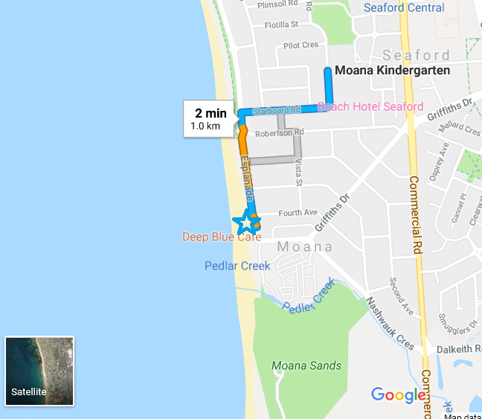

The Beach Kindy day will begin with the children being dropped off at our Beach Kindy home site (off site car parking available for families).

- Parents will check in with the visit leader who will be located at the entrance point near the toilets across from the Moana Surf club.

- Before signing their children in, parents are asked to take their children to the toilet and help them put on their ‘Beach Kindy’ t-shirt.

- There will be a designated spot for the children to place their bags, bottles and lunch box (fruit to be kept in bags).

- After signing their child in, parents are to take their child down to the beach where other staff will be located.

- The children will have a few minutes of free exploration in the designated area as they separate from their parents and settle in.

- Children will then gather, with a formal welcome to Beach Kindy and Acknowledgement of Country. A whole group risk assessment will be conducted with children (risk assessment will have been previously conducted by staff/volunteers) as we say goodbye to siblings and family members not staying.

- Children will then be provided time to explore the environment, work on inquiry topics or participate in planned activities or adventures in the area.

- We will have designated fruit and lunch periods to manage hygiene and safety.

- The length that we stay will depend on weather, levels of engagement and other commitments.

- At the conclusion of the Beach Kindy session, the group will walk to Moana Kindy following identified routes which have been risk assessed.

- The adult: child ratio remains the same unless a child arrives late or is collected early from the site by his or her parent/carer. When this happens, the child is expected to be supervised by their parent/carer during the journey between the child’s home and the site and signed in/out accordingly.

- Children will always be collected at the end of the Kindy session back on site (Schooner Road) unless otherwise notified
Route to and from Beach Kindy Site (in reverse for return travel)

Leave the Kindy by the gate from the outdoor space. Turn left onto Schooner Road. Follow the road around past the school and turn right onto Starboard Road. Cross at the pedestrian crossing area and turn left onto Esplanade. Walk along the footpath and turn onto the beach footpath (away from road) as soon as possible. Walk past the Moana Beach toilet block and enter the Beach Kindy area to the right.

Walking
The staff, children and volunteer helpers walk to site. Any child new to the visit or who requires additional support is closely watched. Time is made to jump in puddles, observe seasonal changes in nature, observe activity within the local community and enjoy the walk as a vital part of the experience.

Crossing the roads
- We cross in small groups and holding hands with a partner, not in single file.
- No-one must stop the traffic nor stand in the middle of the road.
- Staff and volunteers will be evenly dispersed throughout the line.
- We cross where it is safe to do so. We use the pedestrian crossings where they exist.
- We involve the children in looking, listening and deciding when it is safe to cross.

Collection and use of natural materials

Children collect, and use fallen sticks, cones, leaves, shells etc. but leave the plants and trees intact. The children will learn through experience. If a potentially harmful plant or animal is spotted, then everyone knows its location and to leave it alone. If necessary, a temporary visual marker will be provided.

Tree climbing
Some children want to climb trees. When this happens, we follow agreed procedures outlined in our risk benefit assessment and adhere to National Quality Regulations for safe fall heights. Although, there are not many trees appropriate for climbing in the natural beach environment

Dogs, horses and wild animals
We will have signs posted to dog owners and members of the public to ask that they walk outside of the Beach Kindy safe zone. Dogs will appear from time to time with their owners. We remind children not to pat a dog. We help children learn to turn their backs on a dog which is out of control. The party will leave the site if an aggressive dog arrives that gives cause for concern.

Litter
We teach children to be aware of litter. There may be sharp objects, syringes, broken glass, unidentifiable objects which give cause for concern. Any dangerous litter is left alone and reported to the Visit Leader. It is flagged so children know not to pick it up. The leader phones Onkaparinga Council Services to let them know. Gloves, litter pickers and bags are available, so children and adults can collect non-hazardous litter safely. We are particularly careful when finding litter on the beach as it can be hidden between rocks, buried by sand and so on. Children are reminded that they do not touch anything they are unsure of.

Working near the Sea

Children will be engaged in play and adventure on the sand and will not be working near the shoreline. The tide times and tide lines will be carefully monitored by the site leader and a clear boundary for self-exploration will be established.

Visiting the beach

All participants are aware that this program does not include any element of water play, paddling or swimming. No member of the party will go into the sea and the site leader will monitor tidal movements and the shoreline as appropriate. This will take into account the;
- BOM Weather forecast
- Tide times for Moana
- Surf Life Saving SA practical advice.

Tides
Tides will be closely monitored to ensure that safe play can occur on the sand.

Tidal rock pools
If tidal rockpools have formed within the defined area of Beach Kindy, these will be assessed by the site leader to ensure that safe investigations can be undertaken by children. This will be with an adult and all children will be made aware that they are not to touch anything that they are not sure about.

Respecting the beach environment
Remember how important it is to be friendly to the environment around you, and to make sure you do not damage or kill the plants and animals you are observing. The following rules will help you out:

Keep Wildlife Wild
Let birds and other creatures find their own food and keep bread and scraps off the beach

Leave things as you found them
If you lift up rocks, make sure they are small and only look under a few. Place them back carefully. Keep marine creatures in their happy homes; enjoy watching them but leave them where they are.

Leave nothing but footprints
The beach is a delicate wild place. Leave it as you find it and take all litter with you

Watch where you step
Your feet are huge to any animal on a rocky shore, so be careful not to crush or damage some of the more delicate creatures as you step on the rocks. It can be very slippery too, so care is needed. Sand dunes may be hope to birds like the hooded plover, so be mindful when you are in these places.

Safety by the Sea

Respect the Creatures of the Sea
The ocean is full of fascinating forms of life. However, there can be animals that sting or bite if provoked or disturbed. It’s wise to only pick up empty shells and things that are not living such as washed up seaweed, seagrasses and cuttlebones. Be mindful of larger empty snail shells, old cans and bottles and rocky pools of water that can be home to the blue-ringed octopus.
Infection Control

Food hygiene, hand hygiene and toileting outdoors

Food hygiene
Food will be primarily be packed and provided by parents for their individual children. Food is stored in containers or covered until eaten. Uneaten food is put back into containers and disposed of back at the kindy. Food which falls to the ground is put in a litter bin or similar after snack.

Hand hygiene
Moana Kindy acknowledges the hand hygiene advice outlined in ‘You’ve Got What’
Staff will supervise handwashing until a child is able to do this independently using the correct technique.

Toileting
Public toilets will be utilised, and these will be checked before a Beach Kindy session to ensure they are suitable for use. Every child will be escorted to the toilets by an adult and will remain with this adult until they return to the group.

Missing Child Procedures

As part of the routines around the Beach Kindy sessions, the following measures are undertaken to significantly reduce the likelihood of a child going missing:
- Regular head counts are undertaken.
- Gathering call used and practised so that children gather promptly when requested to do so.
- The wearing of brightly coloured clothing and footwear.
- Boundaries are clearly identified with children.
- When on walks, children are encouraged to identify landmarks so that they develop an awareness of where they are at any given point.
- Children know they must play where they are able to see adults.
- The adult: child ratio is sufficient for the children, the site and the range of activities undertaken.
- A register of children and adults attending a session is always carried by session leaders.
- A fully-charged phone with relevant phone numbers is carried by the leader. The phone reception at the site and any black spots are known by all staff.
- Emergency procedures in place and followed should a child go missing.
- Parents and carers advised to inform kindy if family circumstances are such that a child is at risk from abduction or harm. In such instances, an individual risk assessment is undertaken in conjunction with the child’s parent/carer.
If the setting’s policies and procedures are being observed the likelihood of a child being lost or missing is small.

Once a child has been registered each day, then staff are responsible for their whereabouts.

If a child does go missing the following procedures will be implemented:
- All staff present will be informed so that a head count can happen and recall of whereabouts and when the missing child was last seen. A member of staff will search the site.
- Children will be gathered to double-check numbers.
- Staff and volunteers will be deployed to search the site a second time, whilst children undertake a supervised group activity at the gathering place.
- The session leader will be informed of the situation. The session leader will phone the police and the parent/carer.
- The children and group will return to the kindy.
- The kindy director or daily leader will meet with the police and parent/carer.
- Support and reassurance will be offered throughout for parents, staff and children.
- The visit leader will record the incident on the reporting form which will be passed to Department for Education personnel.

Emergency Procedures

Staff in charge of children and volunteers during a visit have a duty to keep the participants in their care safe and healthy. They also have a duty of care to act as a reasonably prudent parent would. Staff should not hesitate to act in an emergency and to take lifesaving action in an extreme situation. Accidents, incidents and near misses all require are reported in line with the Kindy’s Health and Safety policy.

Appendix 1: Visit Leader’s Checklist

Planning Checklist | Date | Date | Date | Date
- Weather forecast checked

- Daily site check completed

- Staff / Director in agreeance that the visit may go ahead

- The equipment has been checked and is ready to go. See appendix 2

- Provision for snacks and drinks has been made

- Appropriate ratios of adults to children have been organised

- Volunteers have been welcomed and briefed

- The children and adults have suitable clothing and footwear

- Rules or expectations shared with the group

- No unsuitable belongings are taken

Whilst on the visit:
- Ensure everyone knows behaviour expectations and boundaries.
- Do head counts.
- Base is established at the site.
- Jobs are assigned as needed.

Back at kindy/school
- Thank volunteers and have informal conversations with parents/carers as usual about their child.
- Any follow up paperwork completed.
- Check equipment, dry and store until next visit.
- Repair or replace any equipment as needed.
- Ensure any accidents, near misses, first aid and incidents are recorded on appropriate forms and that relevant people are informed as required.
- Update risk benefit assessments.

Follow up
- Set aside time the following day to review session with children, e.g. through floor books
- Integrate the experience into the wider life of the kindy – every week.
- Back link the experiences to possible lines of development in the current inquiry

APPENDIX 2. EQUIPMENT LIST

Prior to leaving, the leader should ensure this handbook in an accessible place and all documentation is collated in a central folder.

Check the following equipment is ready:

Equipment Checklist | Date | Date | Date | Date
Fully charged mobile phone for each staff member with relevant phone numbers
Daily Off-site Sign in sheet completed
Toilet / facilities equipment
Plastic bags for small quantities of rubbish created by the group (including dog mess bags)
Children’s backpacks

(Snack, Drink, Spare hat, clothing, etc.)
Hand hygiene bag

Plastic bag for rubbish

Bottle/canister of fresh water, soap, paper towels
Hand wipes
Miscellaneous items:

Spare clothes

First aid bag (keep contents fresh)

Sunscreen

Camera

Beach kindy folder (red bible)
high vis jacket and whistle
Red t shirts for children
Cones and signs to public

APPENDIX 3: DAILY SITE CHECK

(Undertake prior to each visit)

- BOM Forecast is a free weather forecasting service: http://www.bom.gov.au/sa/forecasts/noarlunga.shtml

Hazard | Date Checked by | Date Checked by | Date  Checked by | Date Checked by | Date Checked by | Date Checked by
Weather - temp, wind speed, precipitation,

Sea Conditions

Shoreline / sand conditions
Litter

Dog mess

Landscape or environmental work
Phone reception
Other

Comments including action taken to manage risk are written overleaf, signed and dated.

APPENDIX 4: DAILY OFF-SITE REGISTER

Moana Beach Kindy

Kindy Emergency Contact: 0438 427 146 Phone Number: 8386 1971
Designated Group Leader & Mobile Contact: sophie northcott 0403 893 789

Child | Name |  | Medical/Dietary Information | Care Plan | Permission Forms:  Consent, Sunscreen, other….
1
2
3
4
5
6
7

8

9

10

11
12

Staff | Name | Mobile Phone Number
Site Leader
Staff
Staff

Staff

Staff

Staff

Staff

Staff

Staff

Volunteers

1
2
3
4
5
6
7
8
9
10
11
12

Please attach any other relevant information.

APPENDIX 5: SITE INFORMATION CHECKLIST

Moana Beach Foreshore

Local Council: Onkaparinga City Council Post Code:5169

Contact details of Council: 8488 2003 – Eulonda boulger

SITE MANAGEMENT

CONSIDERATION | Yes/No
Do you have permission to use the site from the owner/manager?

Does the owner have insurance for enabling this to happen?

Do you have a written agreement in place which clarifies remits and responsibilities? (Please attach and keep safe – an email will do)

*Have you permission to:
Lighting a controlled camp fire (NB even a disposable barbecue is a fire)

Are there any “no go” areas e.g. because of safety, wildlife protection, private property, high risk of environmental impact?

Any specific requests re behaviour of the group or management of the beach? For example, if you wanted to plant trees, create paths, undertake environmental stewardship tasks, etc. would this be possible?

Is there any site management work needed before your kindy can use the site? When will this happen?

How robust is the site? Consider how often you will be using the site, the numbers of children and seasonality. You may need options of different areas to use in rotation in order to manage environmental impact.

APPENDIX 6: SITE APPRAISAL – Its suitability for use by your setting

Completed during site visit:

When commenting, you may wish to think about how easily changes could be made to improve an aspect.

ACCESS - In terms of access it is important that the group can enter and leave the site with relative ease. For example, if the ground is too tricky to negotiate then it may be necessary to look elsewhere.

CONSIDERATION | Comment
Is the site within walking distance or will it is necessary to request that parents drop off and pick up children from the greenspace?
Look for safe parking/drop off and assembly points including for emergency access within or just out with the greenspace. Consider other access to the beach too, e.g. by walking or by bicycle. Are there any locked gates, etc.
Think about the network of paths – does this exist? If not, how easy is it to walk across the area, especially for pre-school children?
Terrain– ideally a mix of flat and sloped spaces. Think about its aspect (north or south facing) and when the sun reaches the slope or whether it is in shade during your session.
Boundaries – are there natural boundary features within the area you want to be, e.g. a line of trees, a hedge, path, etc?

Think about a designated place of safety in the event of a serious incident. Is this going to be your setting or another facility that is nearby?
Is there a suitable shelter during inclement weather?

SITE CHARACTER - This is how the place feels. Ideally it should have a feeling of “wildness” about it. Do remember that even small places can feel wild and isolated for a young child.

CONSIDERATION | Comment
- Traffic noise

- Historical evidence, e.g. old walls, buildings, ditches, tracks.

- Variety of plants and fungi, seasonal variation

- Multi-sensory variety: sights, sounds, smells, shapes, colours

- Mix of terrain: dips, hollows, stones, rocky outcrops, etc.

- A variety of places: enclosed, open, to hide, roll, sit, have physical challenge, be quiet, a good view, etc

- Evidence of wildlife. Opportunities to watch wildlife.

- Presence of water, e.g. stream, river, loch, bog/wetland, ditches, sea, etc. and safe access to it.

- Ability of the site to cope with the frequency of your visits, the numbers of people visiting so that environmental impact is minimised.

POTENTIAL HAZARDS
Here the trick is to think about whether these are manageable and the level of risk posed. What can be done to enable visits to go ahead? Bear in mind the risks may also be seasonal. Think about “heads, shoulders, knees and toes” when looking for hazards at different levels.

CONSIDERATION | Comment
- Litter – including drug paraphernalia and sharp objects

- Rocks and outcrops

- Ocean

- Steep drops / sand dunes

- Animal nuisance, e.g. dogs & dog mess, nesting birds

- Toileting options

- Ongoing site work needed: tree felling, footpath improvement, grass cutting, spraying
- Nearby industry which may create pollution (noise, air, land, water, etc.)
Wifi and mobile phone connectivity. Note location of any blackspots.

Any other thought and comments:

POTENTIAL HAZARDS – BEACHES

Here the trick is to think about whether these are manageable, and the level of risk posed. What can be done to enable visits to go ahead? Bear in mind the risks may also be seasonal.

CONSIDERATION | Comment
Litter – particularly broken bottles, sharp objects, unidentifiable objects washed up by the tide

Tides – can you access the beach at high tide?
Is there a risk of getting cut off?

Steep drops – the presence of cliffs or large rock outcrops that are easily accessed by children

Animals – dogs and dog mess, nesting birds, jelly fish, crabs, etc.

Quantity and type of potentially harmful plants (NB Seaweeds are generally harmless)

Security of the area – are there natural boundaries?
What about exits from the beach?

The amount and type of passers by. How much seclusion do you need?

Toileting options

Any other thought and comments:

APPENDIX 7: VISIT PLAN CHECKLIST (V1 FORM)

Site: Moana Kindy
Director:
Visit to: Moana Foreshore
Date: Every Wednesday from **
Number of Students:
Age range:

Level of experience of accompanying staff: (LOW 1 2 3 4 HIGH)

NAME | LEVEL | NAME | LEVEL

Educational objective of the visit: ………………………………………………………………………………………………………..

 | ITEMS TO BE PLANNED | DETAILS  (Highlight once you have achieved)
1 | Information home / consent | Attach copy of the information for parents and annual block consent form  Collate returns and check for important information.  Keep returns in a safe place where office staff can easily access in the event of an emergency.
2 | Venue research | Do at least one pre-visit and check its suitability using site appraisal form (Appendix 6)  Contact owner/manager of site and agree permissions (Appendix 5)  Assess the benefits and the risks of the venue.  Create risk-benefit assessment  Carry out prep work needed with children, parents, staff
3 | Staff / participant ratios | Decide ratios taking due account of policy guidance and local factors  Put out a request for volunteers if needed and follow policy on use of volunteers  Check that staff are suitably competent to manage the visit.
4 | Travel / logistics | Note the intended travel route
5 | Equipment / clothing required | Have backpacks for each child or their own bag  Staff to carry additional items – See equipment list in Appendix 2  Ensure equipment list is compiled and checked before and after each visit
6 | Managing the activity | The Moana Beach Kindy visits involve repeated visits to the same greenspace on a weekly basis all year round. Micro routines are developed to ensure independence and safety. Free play happens the majority of the time.
7 | Medical / health considerations | Check all child’s records for relevant health/medical information and take account of this when undertaking the weekly visits
8 | Weather factors | Do a check the day before and if necessary cancel the visit.  Do another check on the day – Daily Site Check Form
9 | Emergency procedures | Have these in place – see handbook and Section 10 of Council Education Visits policy
11 | Risk assessment completed | See the RBA attachments

Visit approved by Head of Establishment: | YES / NO | Signature | Date | Date for review

Sample letter to parent/carers

This information is in addition to the annual routine and expected block consent form which parents should have signed for local visits within walking distance
Date:

Dear Parent/Carer,
Introduction of the Moana Beach Kindy Program
Aims and Outcomes – outline
Before we begin - give them info about the set up and logistics etc
While we are there – run through what a ‘typical’ day at beach kindy might look like
When we return - discuss possible follow up back at kindy

Our positive approach to risk

We would like to invite you to volunteer at our Beach Kindy sessions. Your child will enjoy showing you the site. It is an opportunity for you to experience our positive approach to risk and how outdoor play is benefiting your child.

When playing outside your child may wish to:
- Play in the sand – making sand castles
- Jump in puddles or discover the joy of paddling in tidal pools.
- Use tools: such as litter pickers for collecting litter or trowels for digging in the soil.
- Play with sticks.
- Balance on fallen logs or small boulders.
- Undertake many other exciting adventurous activities that keep them fit, healthy and curious about the world

Our risk management arrangements
- We do not actively encourage a child to try an activity where there is an element of risk. A child must decide when they are ready to try something new.

- We have clear procedures in place to support those children who do. We consider the benefits to the child and whether these outweigh the risks involved. We have risk-benefit assessments that have considered the foreseeable risks and measures we have put in place to manage these risks.

- We ensure that the identified activities are supervised in proportion to the abilities and confidence of each child. We take the utmost care to ensure the whole experience is as safe as necessary.

- We encourage all parents and carers to ask questions, look at what we are offering and help us to assess and understand the risks. Your thoughts will help make our decision-making stronger and enable children to take positive, appropriate risks within a framework of safety.

Please can you sign to indicate you are aware of the experiences being offered and approve of the risk management arrangements in place. If you have questions or comments, please let us know.

Yours sincerely

Kindy Director

Beach Kindy sessions and outdoor play

Child’s name____________________________________

I have read the information about the positive approach to risk taking including our risk management arrangements. By signing, I indicate my approval.

Signed _____________________________________________ Date ____________________________

Name _______________________________________________

Comments or questions

