|  |  |
| --- | --- |
| **Site name** | Moana Kindergarten (UPDATED RISK ASSESSMENT 2022) |
| **Destination, method of transport (including proposed route)** | Parents/ carers drop off children at Beach Kindy home site (near Moana Surf Live Saving Club/ toilets)  Walk past the Moana Beach Northern Toilet block, walk on the footpath along the Esplanade, safely cross at the roundabout turning right onto Starboard Road, bear left around past the school onto Schooner Road, then turn right into kindergarten. |
| **Date and time of departure/return** | Wednesdays (Odd weeks TURTLES & Even weeks ROSELLA). 8:45am arrival at Moana Beach and return to kindy midday. (weather permitting) |
| **Proposed activities** | Beach Kindergarten Program |
| **Class and year level** | Kindergarten |
| **Number of children/ young people** | 33 (or smaller groups depending on attendance: currently 27 Turtles/31 Rosellas enrolled on designated day) |
| **Number of employees/ volunteers** | No less than 5 educators and 2 parent helpers and/or volunteers  Adult to child ratio 1:5 or less. |

|  |  |  |  |  |  |
| --- | --- | --- | --- | --- | --- |
| **Key contacts** | | **Name** | | **Contact No** | |
| Site leader | | Samantha Duell | | 0447 082 806 | |
| Teacher-in-charge/responsible person | | Samantha Duell, Kerry Addison, Jess Reid | | 0412 797 771 / 0417 170 641 | |
| Alternative teacher contact | | Leah Bunney | | 0402 094 697 | |
| Health and safety representative | | Site Leader/ or Lead teacher | | 0438 427 146 | |
| Site point of contact | | Samantha Duell | | 8386 1971 | |
| First aider | | All educators | | 0438 427 146 | |
| **APPROVAL**  **Acknowledgement:** Safety risks have been identified for the listed camp / excursion with controls implemented to effectively manage risks to the health and safety of participating employees, volunteers, children, and young people.  Requirements in this document must not be altered and it must be available at the site for parent inspection requests. This form must be completed to ensure compliance with the Education and Care Services National Regulations and departmental policy before seeking parent/legal guardian consent and before a camp or excursion takes place. | | | | | |
| **Position** | **Name** | | **Signature** | | **Date** |
| Teacher-in-charge | Lead Teacher –  Samantha Duell/ Kerry Addison | |  | | 28/03/2022 |
| Site leader | Samantha Duell | |  | | 28/03/2022 |

|  |  |
| --- | --- |
| **Minimum requirements** | |
| **Planning** | * 1 teacher is assigned as the teacher-in-charge, as the delegate of the site leader, to provide leadership and control of the camp or excursion. * The venue for excursion or camp location is reviewed in the initial planning stage to determine the suitability of location. The location must have an emergency management plan. * The emergency management plan in this form is reviewed and updated, if required. * For a sporting or adventure activity, the [camps and excursions guideline](https://edi.sa.edu.au/library/document-library/controlled-guidelines/camps-and-excursions-guidelines-for-schools-and-preschools-guideline.pdf) must be followed; the instructor competency and supervision ratios must be adhered to. * A parent or guardian signs the excursion/camp [consent form](https://edi.sa.edu.au/library/document-library/form/early-childhood/ED170-consent-form-for-camp-or-excursion.doc). * Weather forecast to be checked leading up to and during the camp/ excursion. * Monitoring of CFS bushfire alerts and special consideration for camps in bushfire prone areas. Cancel the camp/excursion if the destination is in a bushfire prone area during an extreme fire danger warning, a total fire ban or if there is a bushfire. * Ensure appropriate communication devices with adequate service coverage are available. * For activities without a [prescribed ratio](https://edi.sa.edu.au/library/document-library/controlled-guidelines/camps-and-excursions-guidelines-for-schools-and-preschools-guideline.pdf), or the risk assessment does not indicate a higher ratio is required, the minimum supervision ratios are in place:   + **1:6 for preschools to year 2**   + 1:10 for years 3-7   + 1:15 for years 8-12. * Ensure there is adequate supply of water and food, sun protection and appropriate clothing for weather conditions. * List of children and adults attending the camp/excursion and contact information for each person. |
| **Conduct and behaviour** | * Children and young people follow the [school behaviour code](https://edi.sa.edu.au/supporting-children/behaviour/behaviour-support/developing-a-code). * Supervisory staff team members follow the [Code of Ethics for the South Australian Public Sector](https://edi.sa.edu.au/hr/for-individuals/about-you/your-responsibilities). * Supervisory volunteer team members follow the Expected Behaviours for Volunteers, outlined in the [Volunteer Agreement](https://edi.sa.edu.au/operations-and-management/school-preschool-and-fdc-admin/managing-volunteers/volunteer-forms). * All supervisors, including parents, volunteers and instructors must hold a [child related screening clearance](https://www.education.sa.gov.au/working-us/relevant-history-screening) in accordance with the [Screening and suitability (child safety) policy](https://edi.sa.edu.au/library/document-library/controlled-policies/screening-and-suitability-child-safety-policy.pdf). * Volunteers have met screening and suitability requirements, completed an [induction](https://edi.sa.edu.au/operations-and-management/school-preschool-and-fdc-admin/managing-volunteers/volunteer-requirements), are aware of [protective practice guidelines](https://edi.sa.edu.au/supporting-children/child-protection/your-responsibilities/protective-practices-guidelines). * All participants are briefed on any identified conditions of the children/young people, the emergency and contingency plans, any relevant specialized or technical skills of supervisory team members, their roles and responsibilities and any relevant hazards. * Children and young people are accounted for at regular intervals; with a head count occurring each time children/young people board and disembark transport; and enter and leave the location, checked against the attendance record. * Alcohol or drugs must not be consumed; and supervisors must not smoke within 10 meters of the camp perimeter or in view of children/young people. |
| **First aid** | * For camps and adventure activities 1 person is trained in ‘HLTAID004 – emergency first aid’ in education and care settings for every 25 people. * Where it may take greater than 2 hours for medical assistance or a medical retrieval to arrive, at least 1 first aider must be trained in ‘HLTAID005 –first aid in remote situations’. * For excursions, consider the risks of the location or activity being undertaken; and any pre-existing medical conditions of the participants. Ensure that you have one of the following:   + a designated first aider in the group   + a teacher trained in first aid   + a first aider available at the location   + access to local area GP/medical facilities   + a paramedic in close proximity. * Appropriate type of first aid kits is available e.g. basic first aid kit for each first aider, remote first aid kit, EpiPen etc. * The first aiders have a copy of any [individual first aid plan](https://edi.sa.edu.au/supporting-children/health-and-wellbeing/health-condition-plans-and-forms/medication-management) where a child or young person has a known health condition and the first aid response is NOT the standard first aid response for that health condition. * Medications required for children and young people must be easily accessible and secured to prevent unauthorised use. * Leadership team provided with medical information for each child (where applicable). * Children and young people with [complex and invasive health needs](https://edi.sa.edu.au/supporting-children/health-and-wellbeing/health-services-and-programs/complex-and-invasive-health) must be provided with the opportunity to attend camps/excursions and be supported by a competent person to manage their health needs. |
| **Transport** | * The bus is fitted with a current safety label (safety triangle on windscreen) and the bus driver holds a valid licence. * The bus company has a contingency plan in the event of mechanical failures. * Private motor vehicles are used as a last resort with a written agreement signed prior to the event (use the agreement in the [guideline](https://edi.sa.edu.au/library/document-library/controlled-guidelines/camps-and-excursions-guidelines-for-schools-and-preschools-guideline.pdf) for parents and use [ED008](https://edi.sa.edu.au/library/document-library/form/operations-and-management/procurement/fleet-management/private-motor-vehicle-on-government-business-approval-to-use.pdf) for employees). * Driver’s licences are unrestricted and valid; “L” plate drivers are not to transport children or young people. * Complete a [long distance travel plan](https://edi.sa.edu.au/library/document-library/form/hr/health-and-safety/hazards/long_distance_travel_management_plan.docx) if an employee is driving greater than 300kms in a rural location. |

Follow the steps on page 4 and in the table below and list any additional hazards and controls for your sport, adventure, camp, and excursion that are not already listed on page 2 of this document. The safety requirements outlined in section 8 of the [camps and excursions guidelines](https://edi.sa.edu.au/library/document-library/controlled-guidelines/camps-and-excursions-guidelines-for-schools-and-preschools-guideline.pdf) identify further hazards and controls that may also need to be considered.

**NOTE: Early childhood sites must identify and address all water hazards.**

|  |  |  |  |  |
| --- | --- | --- | --- | --- |
| **Sports, adventure, camps and excursions risk assessment for additional hazards** | | | | |
| **Hazard identification**  (What is the issue of concern?) | **Risk controls**  (What are you doing to eliminate or mitigate the issue?) | **Residual risk** (All controls in place) | | |
| **Likelihood** | **Consequence** | **Risk rating** |
| Child being hit by vehicle | * Adult / child ratio and constant supervision. * Access Road is via Schooner, starboard and esplanade * Educate children about road safety and identify areas where cars may be a hazard (esplanade car park– particularly at drop off times & cars sometimes parked south side of beach) * Boundary training for all children – they do not go near the car park * Walk back in partners * Use road crossing islands to return to kindy | rare | Major | medium |
| Child getting lost | * Preschool children to wear red Beach Kindy T shirt with Kindy mobile number and name written on the back (base) of t shirt * Adult / child ratio and constant supervision. * Regular head counts throughout the day - leader to do * Program planning, selection of appropriate location (in consultation with Caretaker) and familiarising children with Moana Beach - mat will be home base * Moana Beach Kindy mobile phone number attached to children’s clothing * Children to be taught procedure if lost - stay in one place (do not move) and call out. * Children to know they need to have the visible boundaries (flags) in their line of vision when playing (or with an adult present). | Rare | Major | medium |
| Child hit by rock / sticks  - broken limb/other serious injury | * Selection of appropriate areas for Nature Kindy in consultation with Caretaker. * Stocked first aid kit and operational mobile phone carried at all times. * First aid trained staff | Unlikely | Moderate | Medium |
| Hazardous rubbish, such as syringes, glass, etc. | * Staff to carry out site inspection prior to the program starting to identify any hazard. * Cordon off identified rubbish that may be considered dangerous * Children are not to access the area behind the sand dunes | Rare | Major | Medium |
| Dog charge / bite / bark | * Dog safety awareness of children session provided annually. * Protocol established for Kindy staff to be on alert for ‘dogs off lead’ and to alert staff and children if a dog is in range. * Staff to ensure children follow appropriate procedure –   + Stand still   + Arms by side   + Look down   Staff to manage controlled and supervised interactions with dogs where appropriate.  Children are reminded that they are not to pat dogs  Area in use for Beach Kindy has a sign asking local community to be aware of children on the beach and to walk around the area if possible and keep dogs on leash near area | Unlikely | Moderate | Medium |
| Drowning/Near Drowning | * Adult / child ratio and constant supervision on foreshore. * Stocked first aid kit and operational mobile phone carried at all times. * First aid trained staff * Program planning / site(s) chosen / water /environmental education as part of program * If visiting beach, staff to carry out pre-site inspection to gauge strength of water flows and identify any hazards i.e. slippery rocks * Avoid visiting creek after rain events due to high flows * Staff member to stand near water line * Flagged area in front of water – children are not allowed to go in the water | Unlikely | Moderate | Medium |
| Snake bite | * Stay a recommended distance from water and long grass and sandune area during warmer months (education of staff and children with Caretaker). * If visiting the sand dunes, staff to carry out pre visit site inspection and remain on alert * Clothing requirements advised to parents i.e. – rubber boots / long pants. * Program planning /site(s) chosen / wildlife education * Stocked first aid kit and operational mobile phone carried at all times. * First aid trained staff * Emergency contact numbers for children and staff carried. | Rare | Moderate | Medium |
| Insect bite / sting.  Ingestion of or reaction to plant/other material. (e.g sea creature or allergic reaction) | * Protective clothing / education of children as part of Nature Kindy program. * Stocked first aid kit and operational mobile phone carried at all times. * First aid trained staff * Request allergy information from parents as per normal Kindergarten procedure. * Carry Emergency Action Plans and Epi-pens and Asthma Medication for relevant children. * Use of repellent approved by Parents/Kindy Governing Council. | Unlikely | Moderate | Medium |
| Seagull / Bird of Prey – biting child, eating their food | * Education of children as part of Nature Kindy program about bird behaviour * Children to sit down and eat lunch in designated area * Lunchboxes to be put back in bags after children have eaten and stored in trolley with cover over | Unlikely | Minor | Low |
| Stranger interference | * Children are not to access toilet block on their own. Staff member to check toilets prior to children using. * Adult / child ratio and constant supervision. * Protocol established for Kindy staff to model appropriate interactions with other users of Moana Beach and to limit contact with other parties that could disrupt the program. * Signage displayed to alert park users of Nature Kindy Program in progress. * High visibility clothing identifiers supplied children. | Unlikely | Insignificant | Low |
| Sunburn/ Heat Exposure / Extreme Weather conditions | * Monitor weather conditions ahead of each week’s session. * Stocked first aid kit and operational mobile phone carried at all times. * First aid trained staff * Protective clothing – coats, beanies, hats, boots, sleeves * Nature Kindy visits occur during terms 2 and 3 and at times in Term 1 and 4 – weather dependent. * Children bring water bottles and water available. * Apply Kindy sun safety policy and we will have extra spare hats. * Sunscreen provided and parents briefed on need to apply sunscreen and dress children appropriate to weather conditions. | Unlikely | Minor | Low |
| Poison/ sting/ bite  Sea creatures - Blue Ringed Octopus, Crab, Sea urchins, jelly fish | * Program and planning, risk assessments with children about local sea life * Children are not to pick up litter * Supervision * Children have a strong understanding of sea life | Rare | Moderate | Medium |
| Sand in eyes | * Monitor weather conditions * Stocked first aid kit with eye wash. | Likely | Insignificant | Low |
| General slips, trips and minor falls | * Educate children around risks, and complete Risk Benefit assessment with children and staff. * Area observed for possible trip hazards. * Stocked first aid kit to support care. | Possible | Minor | Medium |

|  |
| --- |
| **Sports, adventure, camps and excursions risk assessment for additional hazards** |

**Step 1:** Identify any additional hazards.

**Step 2:** Identify controls to eliminate or mitigate the risk using the Hierarchy of Control below.

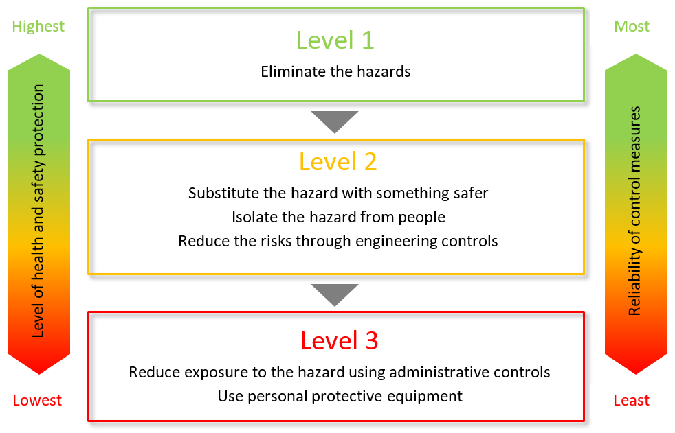

← The ways of controlling risks are ranked from the highest level of protection and reliability to the lowest as shown

**Step 3**: Assess the risk of the identified hazard assuming all controls are in place



**Step 4**: Review the risk descriptors for direction on suitability of the activity and appropriateness of the controls



**Other items that should be taken on the camp/excursion**

List any other items (in addition to the minimum items listed above) that will be needed on the camp or excursion

|  |  |
| --- | --- |
| Teaching resources documented on running record/ program |  |
| Beach Kindy Boxes   * Pink rope * Red t-shirts |  |
| Beach Kindy Handbook (complete) |  |
|  |  |
|  |  |
|  |  |
|  |  |
|  |  |
|  |  |
|  |  |
|  |  |
|  |  |
|  |  |
|  |  |
|  |  |
|  |  |
|  |  |
|  |  |
|  |  |
|  |  |
|  |  |
|  |  |

|  |
| --- |
| **Emergency management plan** |
| 1. Provide immediate first aid assistance or care prescribed by an individual health support plan and/or isolate any person with an infectious disease. 2. Call **000** and advise them of the closest vehicle entry point. 3. Ensure communication with emergency services is maintained. 4. Send an employee or volunteer to the point where emergency services will enter the location, if it is safe to do so. 5. Collect the attendance list, individual first aid plans and this plan. 6. Evacuate all people to the nominated emergency assembly point. 7. Once at the assembly point, check all people are accounted for. 8. Maintain a record of actions/decisions undertaken and times. 9. Report the emergency/evacuation to the site leader of the school or preschool by using the agreed form of communication tool i.e. mobile phone. 10. Site leader will then notify:  * Education Director * Report on IRMS as a notifiable incident.  1. Wait for emergency services to arrive or provide further information/instruction. 2. Teacher in charge to arrange for parents to be informed. |
| **Note method for communicating with the school/preschool contact:**  The school/preschool contact must be contactable at all times, have a copy of this risk management form, be aware of the emergency management plan, have the attendance lists, child/young person health and personal care information, contact numbers of parents/legal guardians, and the itinerary. |
| **Note nearest suitable transport:** |
| **Note distance from help and method for obtaining it:** Educator will be carrying backpack with first aid equipment, as well as site mobile phone to call emergency services/ caregivers if help required. |
| **List any additional contingencies (ie in the event a person becomes lost):** |

|  |
| --- |
| **Call-in procedure** |
| The following process must occur when the camp or excursion is in a remote or isolated location.   1. The teacher-in-charge or delegate must contact a designated person at the site to inform them they have safely arrived; and call prior to leaving the camp or excursion location with an estimated time of arrival back at the site. 2. The teacher-in-charge must provide a time that the check-in will occur. 3. If the check-in does not occur after 20 minutes of the agreed time, the site designated person must phone the teacher-in-charge or an alternative contact. 4. Once 2 unsuccessful attempts have been made to contact the teacher-in-charge or alternative contact within 30 minutes the designated person at the site must inform the site leader and call 000 for police assistance. |

**Emergency management map for your remote or isolated destination**

The below map is not required in built-up residential areas. It is only required when an ambulance station is not within 30kms of the camp or excursion location. You must include as indicated in your emergency management plan the emergency vehicle access point and the emergency assembly point.

**GPS coordinates**

Plus code: ; or

Latitude: Longitude:

|  |
| --- |
| **Remote or isolated location:** |
| **NOT APPLICABLE** |

**Note:** Obtain your site map through [Google Maps](https://www.google.com.au/maps) by searching for your destination; press “Alt + PrtScn” buttons on your keyboard (this will copy the map to your clipboard); click the sample map above and press “Ctrl + V” to insert your new map.

Use the “text Box” function to identify key points such as “Emergency Assembly Points” and “Activity area” etc.